Joseph Silva Jr.

10/10/2021

SNHU

IDS 403 Milestone 4

**Natural and Applied Sciences Lens Analysis:**

The natural and applied sciences are sciences such as biology, chemistry, physics, etc. When it comes to device such as the Oculus Quest 2 Virtual Reality, the video games use these sciences for the system, user interfaces, apps, and controls. We can see Biology and Physics be affected with the use of a Quest 2 system such as Guardian. Guardian uses video cameras and recording devices to create a virtual barrier to protect the user from crashing into the surrounding designs of the residence and showing a visual design for the user to be able to see. Please see the photo below of an example of the Guardian system.

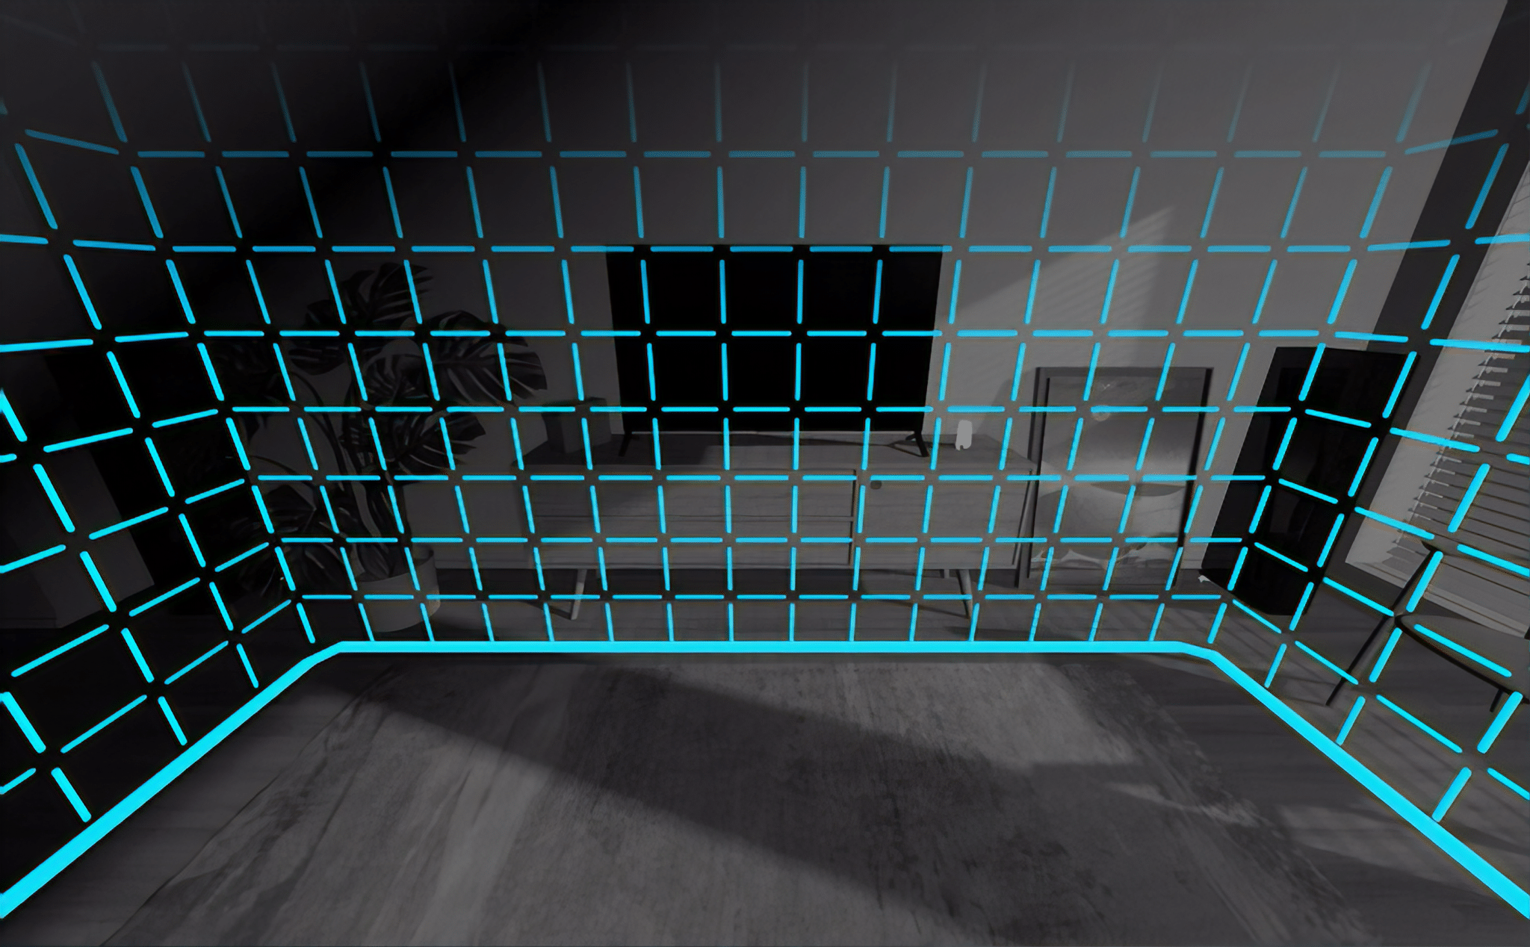

Overtime, these systems and apps that affect users’ senses can be used to help with many medical issues such as mental health conditions and sensory malfunctions. For example, these virtual reality devices use the metaverse to create training seminars and scenarios for doctors and patients. Doctors can use the metaverse to create scenarios for virtual surgery for practice without having any major issues.

**Social Sciences Lens Analysis:**

When it comes to Social Sciences, these are the sciences that affects the social connection with individuals from the same or different communities with one another. These virtual reality systems allow virtual communities to develop, and it allows different users to view other types of communities. These virtual realities allow the users to connection with each other on a deeper level than social media or regular gaming. Users can experience new visual experiences with one another, and these new experiences allow the users within the community to learn about other points of view from members of the same or different community. The Quest 2 device has implemented apps to allow users to learn about these different communities by experiencing many different cultures through virtual reality. Users can use apps such as the “American Experience” and “Mondly: Learn Language in VR” virtual reality apps to give tools to experience these cultures. Please see the photos below for examples of these apps.

**American Experience Mondly: Learn Language in VR**

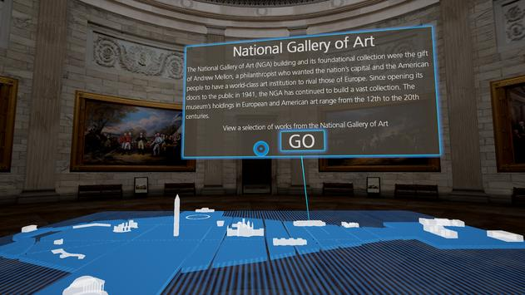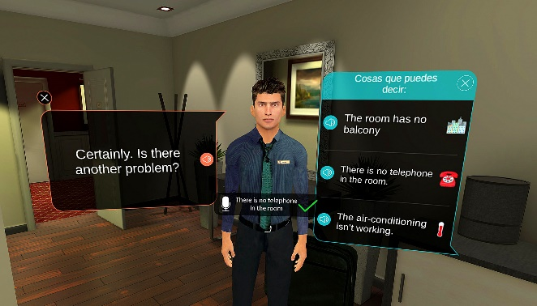

**CITATION:**

1. *The Science of Virtual Reality*. The Franklin Institute. (2020, January 2). Retrieved October 9, 2021, from <https://www.fi.edu/virtual-reality/the-science-of-virtual-reality>.